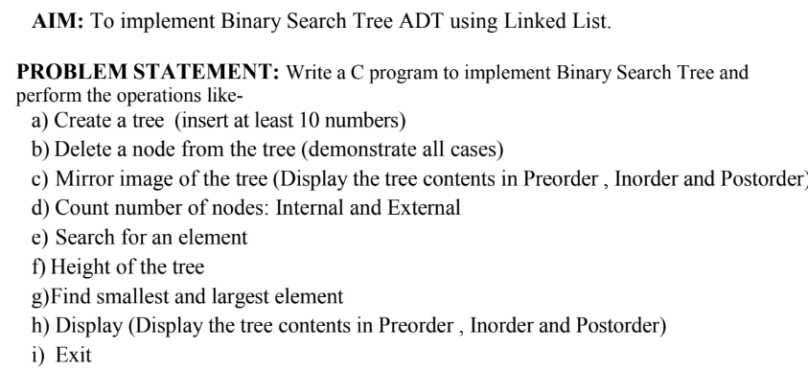

#include <stdio.h>
#include <stdlib.h>
struct node {
int data;
struct node *left, *right;
};
struct node* createNode(int v) {
struct node* n = (struct node*)malloc(sizeof(struct node));
n->data = v; n->left = n->right = NULL;
return n;
}
struct node* insert(struct node* root, int v) {
if (!root) return createNode(v);
if (v < root->data) root->left = insert(root->left, v);
else if (v > root->data) root->right = insert(root->right, v);
return root;
}
void inorder(struct node* r){ if(r){ inorder(r->left); printf("%d ",r->data); inorder(r->right);} }
void preorder(struct node* r){ if(r){ printf("%d ",r->data); preorder(r->left); preorder(r->right);} }
void postorder(struct node* r){ if(r){ postorder(r->left); postorder(r->right); printf("%d ",r->data);} }
struct node* findMin(struct node* r){ while(r && r->left) r=r->left; return r; }
struct node* findMax(struct node* r){ while(r && r->right) r=r->right; return r; }
struct node* deleteNode(struct node* r,int v){
if(!r) return NULL;
if(v<r->data) r->left=deleteNode(r->left,v);
else if(v>r->data) r->right=deleteNode(r->right,v);
else {
if(!r->left){ struct node* t=r->right; free(r); return t; }
else if(!r->right){ struct node* t=r->left; free(r); return t; }
struct node* t=findMin(r->right);
r->data=t->data;
r->right=deleteNode(r->right,t->data);
}
return r;
}
int height(struct node* r){ if(!r) return 0; int l=height(r->left), h=height(r->right); return (l>h?l:h)+1; }
struct node* mirror(struct node* r){
if(!r) return NULL;
struct node* t=r->left;
r->left=mirror(r->right);
r->right=mirror(t);
return r;
}
void countNodes(struct node* r,int* in,int* ex){
if(!r) return;
if(!r->left && !r->right)(*ex)++;
else{ (*in)++; countNodes(r->left,in,ex); countNodes(r->right,in,ex); }
}
struct node* search(struct node* r,int key){
if(!r || r->data==key) return r;
if(key<r->data) return search(r->left,key);
return search(r->right,key);
}
int main(){
struct node* root=NULL;
int ch,v,in,ex;
printf("\nEnter 10 numbers to create BST:\n");
for(int i=0;i<10;i++){ scanf("%d",&v); root=insert(root,v); }
while(1){
printf("\n\n1.Delete node\n2.Mirror tree\n3.Count nodes\n4.Search\n5.Height\n6.Smallest & Largest\n7.Display\n8.Exit\nEnter choice: ");
scanf("%d",&ch);
switch(ch){
case 1: printf("Enter value to delete: "); scanf("%d",&v); root=deleteNode(root,v); break;
case 2: root=mirror(root); printf("Tree mirrored.\n"); break;
case 3: in=ex=0; countNodes(root,&in,&ex); printf("Internal=%d External=%d\n",in,ex); break;
case 4: printf("Enter element to search: "); scanf("%d",&v);
if(search(root,v)) printf("Found\n"); else printf("Not found\n"); break;
case 5: printf("Height of tree: %d\n",height(root)); break;
case 6: printf("Smallest=%d Largest=%d\n",findMin(root)->data,findMax(root)->data); break;
case 7: printf("Inorder: "); inorder(root);
printf("\nPreorder: "); preorder(root);
printf("\nPostorder: "); postorder(root); break;
case 8: exit(0);
default: printf("Invalid choice\n");
}
}
}

